iFIT Prosthesis Spool Repair/Installation Instructions
The steel cables and cable notches adjustment mechanism for tightening and loosening the iFIT Prosthesis has been replaced by a spool mechanism to improve ease of use for patients and prosthetists. This guide will help users and prosthetists assemble the spool mechanism accurately to ensure effective use of the iFIT Prosthesis.
Spool Orientation and Fastening
Transtibial Prosthesis
Narrow Transtibial Prosthesis
Transfemoral Prosthesis
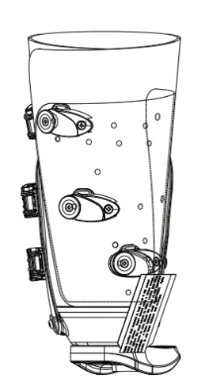
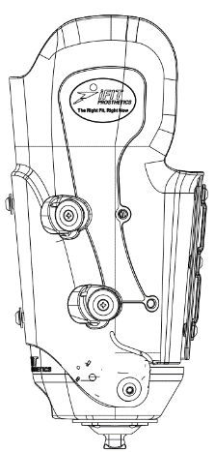
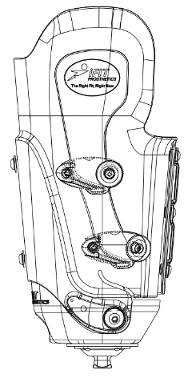

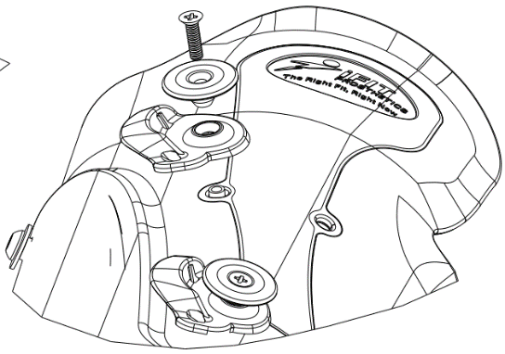
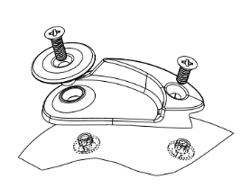

Screw Length for the Appropriate Prosthesis
 | Spool Side |  | Cord Fastening Side
Prosthesis | Philips Flat Head | Chicago Head Screw | Philips Flat Head | Chicago Head Screw
TT200N Narrow Transtibial Socket | 5/8 | 3/16 | N/A | N/A
TT200 Transtibial socket | 5/8 | 3/16 | 1/2 | 3/16
TF300/TF300W Transfemoral Nylon Flap | 1/2 | 1/8 | 3/8 | 1/8
TT250W Transtibial Socket | 5/8 | 1/4 | 1/2 | 1/4
TT250 Transtibial Socket (Top, Middle, Bottom) | 3/4, 3/4, 5/8 | 1/4 | 5/8, 1/2, 1/2 | 1/4

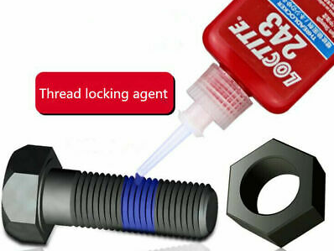
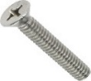
- Ensure Loctite 222 is applied to the screw and the screw is tightened with a torque wrench set to 2 Nm.
Failure to do so could result in screw - loosening. This would cause the spool to detach and the prosthetic to loosen unexpectedly which could result in injury to the user.

- Always place a washer on the inside of the prosthesis behind the spool when using on the transtibial socket.
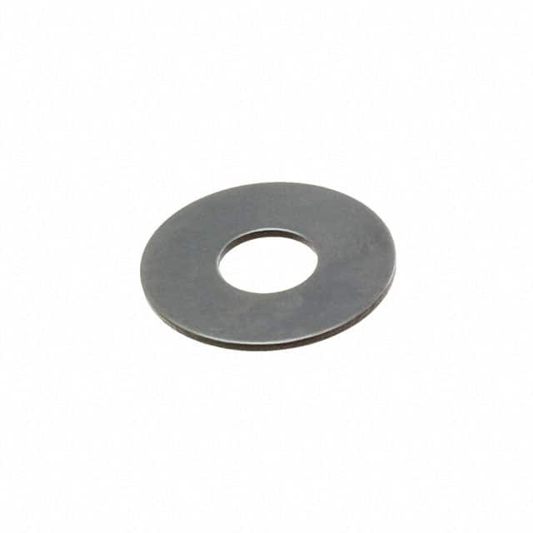
Failure to do so could result in the spool pulling out of the material. This does not need to be done on the transfemoral socket.

Suggested Rope Length to Provide
Prosthesis | Top spool | Middle Spool | Bottom Spool
TT300 | 60 cm | 60 cm | 60 cm
TT300W | 80 cm | 80 cm | 80 cm
TT250 | 120 cm | 100 cm | 80 cm
TT250W | 160 cm | 140 cm | 120 cm

