**iFIT Prosthesis Spool Instructions**

For greater flexibility for you and your patients we now have an additional system for adjusting the buckle tightness. A spool mechanism is included with your kit as another means for your patients to close the socket. This guide will help users and prosthetists assemble the spool mechanism accurately and ensure effective use of the iFIT Prosthesis. Some of the advantages of the spool are: the patient can buckle and unbuckle without adjusting, larger adjustments can be made versus the hook, and the cord is easily replaced if needed.

**Cord threading and securing**

**Cord Fastening Side**

**Spool Side**

**The cord cannot just be wrapped around the spool to be secured as shown above.**

The cord must be thread through the side opposite of the spool and secured with a reef knot (shown above) or slip knot.

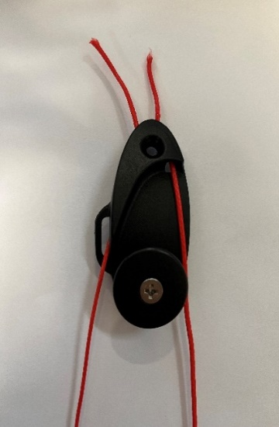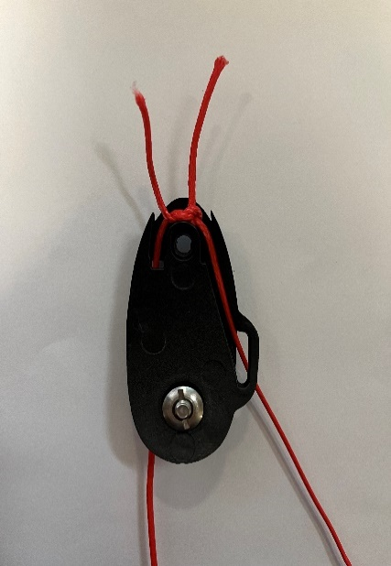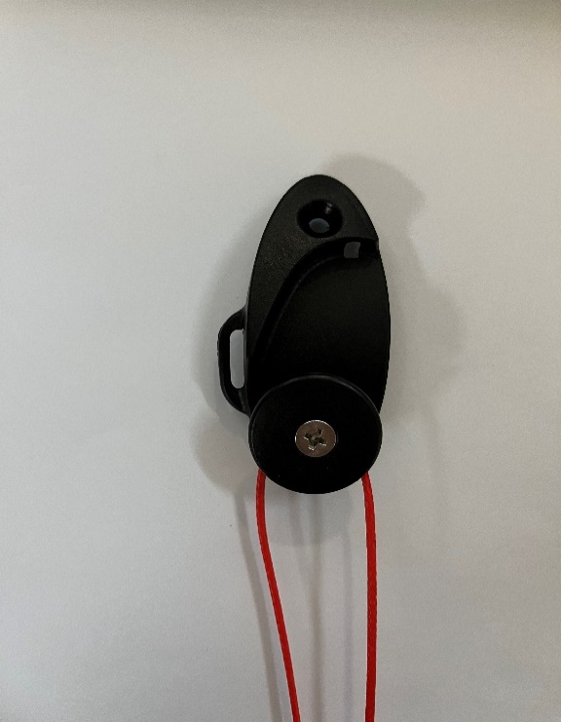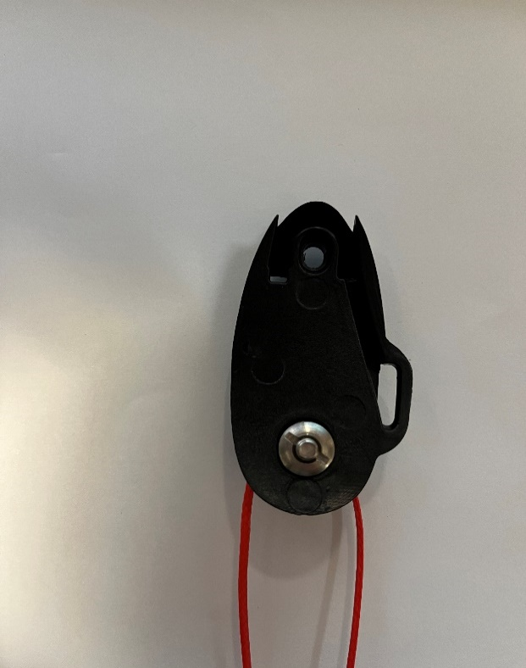

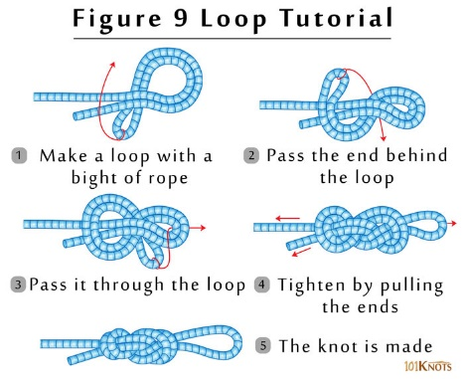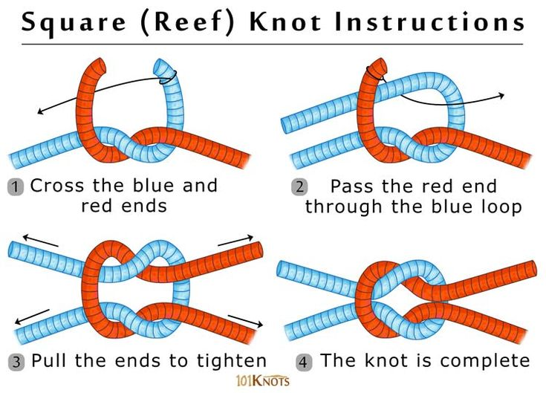**Knot types: Reef and Loop Knot**

**Cord type**

Ensure the cord chosen carries a load of **at least 220 lbs**. ­The cord should be weather resistant and non-stretch. We recommend the Sterling Nylon mini Accessory Cord: sizes 2 mm or 2.75 mm.

**Avoid low friction cords like UHMWPE and PE based cords such as Dyneema and Spectra to prevent the knot from untying and the prosthesis from unintentionally loosening or falling off.**

Be sure to advise the patient to inspect the cord for any fraying or signs of excessive wear. The prosthetist should be notified immediately and the cord replaced.

**Use Instructions**

***Please note the TT and TF spools are threaded in the same manner. The example below shows the TT spool***

* 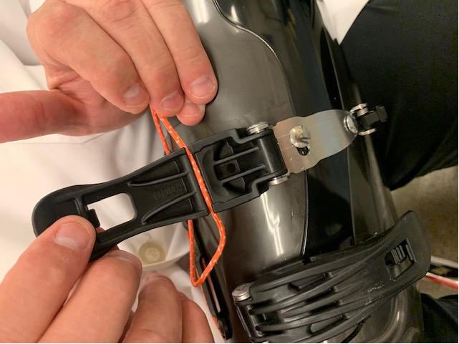To lace the prosthesis, first insert the cord into the buckle

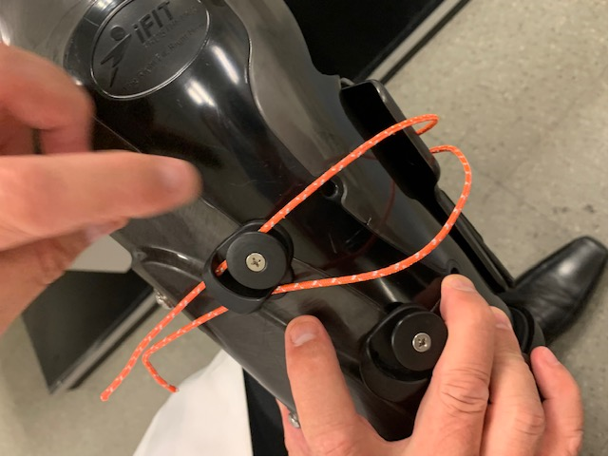

* Next, thread the laces through the holes of the spool.

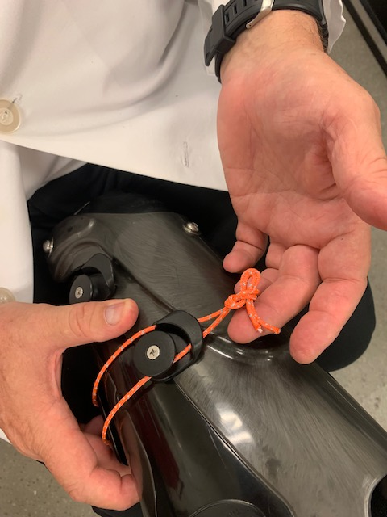

* To determine the cord length, close the prosthesis and pull the cord to where it is loosely closed around the limb. Then, tie a knot by following the instructions presented on the other side of this instruction sheet found under the heading, “Knot Types”. A loop knot is shown in this figure.

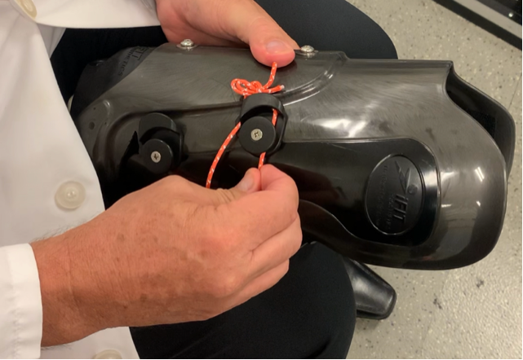

* Open the prosthesis back up and loop the cord the spool 1-3 times. Close the prosthesis and have the patient stand. If adjustments need to be made, open the buckle and either wrap the cord around the spool again to tighten the prosthesis or unwrap the cord around the spool to loosen the prosthesis. The goal is for the patient to have a comfortable and snug closure of the prosthesis around their residual limb.
* If optimal tightness is not able to be achieved by the method above, untie the knot, loosen or tighten the cord to optimal tightness for the patient, and retie the knot. You can also unwind and rewind the loops as they will sit slightly different each time.
* 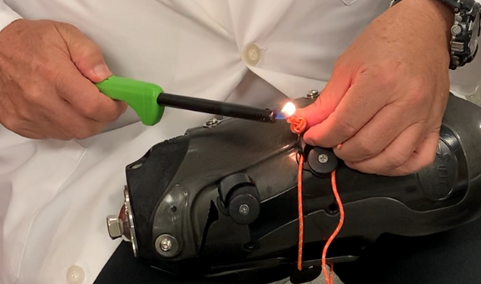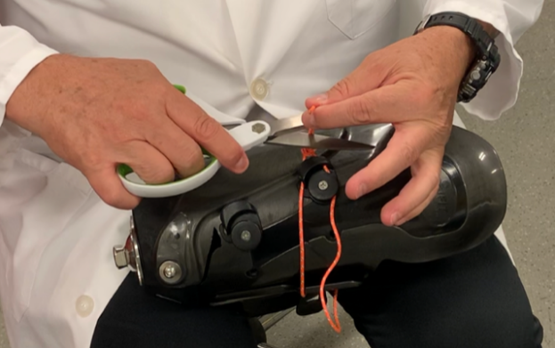Once optimal tightness is achieved, you can pull through the loop and cut the ends (pictured left). This leaves a knot at the correct length. Use a lighter (pictured right) to seal the ends of the cord so they do not fray (only works with nylon or polymer cords).
* The patient can simply buckle and unbuckle the prosthesis for donning and doffing—no more finding the hook locations with the cable ends. They should not need to adjust the spool to don or doff unless they are experiencing changes in volume.
* Should the patient experience a volume change, open the buckle and wrap the cord around the spool to tighten the prosthesis or unwrap the cord around the spool to loosen the prosthesis. Continue wrapping or unwrapping until optimal tightness is achieved.
* If optimal tightness is not able to be achieved by the method above, untie the knot, adjust the cord length, and retie the knot.

**Installation, Moving, or Replacing Spool Parts**

* Use Loctite 222 or equivalent threadlocker and tighten screws to 2Nm.

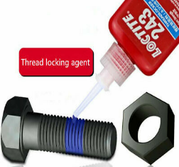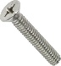

**Failure to do so could result in screw loosening. This would cause the spool to detach and the prosthetic to loosen unexpectedly which could result in injury to the user.**

* Different length screws are used on the spools, ensure adequate thread engagement by using the correct length. Refer to spool instructions V3 for images showing the spool side vs. cord fastening side.
* Be sure the spool has a washer behind it when installing.